**Spring Core Maven**

**Exercise 4: Creating and Configuring a Maven Project**

**Scenario:**

You need to set up a new Maven project for the library management application and add Spring dependencies.

**Steps:**

1. **Create a New Maven Project:**
   * Create a new Maven project named **LibraryManagement**.
2. **Add Spring Dependencies in pom.xml:**
   * Include dependencies for Spring Context, Spring AOP, and Spring WebMVC.
3. **Configure Maven Plugins:**
   * Configure the Maven Compiler Plugin for Java version 1.8 in the pom.xml file.

**pom.xml**

<project xmlns="http://maven.apache.org/POM/4.0.0"

xmlns:xsi="http://www.w3.org/2001/XMLSchema-instance"

xsi:schemaLocation="http://maven.apache.org/POM/4.0.0

http://maven.apache.org/xsd/maven-4.0.0.xsd">

<modelVersion>4.0.0</modelVersion>

<groupId>com.library</groupId>

<artifactId>LibraryManagement</artifactId>

<version>1.0</version>

<packaging>jar</packaging>

<dependencies>

<!-- Spring Core (Context) -->

<dependency>

<groupId>org.springframework</groupId>

<artifactId>spring-context</artifactId>

<version>5.3.32</version>

</dependency>

<!-- Spring AOP -->

<dependency>

<groupId>org.springframework</groupId>

<artifactId>spring-aop</artifactId>

<version>5.3.32</version>

</dependency>

<!-- Spring WebMVC -->

<dependency>

<groupId>org.springframework</groupId>

<artifactId>spring-webmvc</artifactId>

<version>5.3.32</version>

</dependency>

</dependencies>

<build>

<plugins>

<!-- Java 1.8 Compiler Plugin -->

<plugin>

<groupId>org.apache.maven.plugins</groupId>

<artifactId>maven-compiler-plugin</artifactId>

<version>3.8.0</version>

<configuration>

<source>1.8</source>

<target>1.8</target>

</configuration>

</plugin>

<plugin>

<groupId>org.codehaus.mojo</groupId>

<artifactId>exec-maven-plugin</artifactId>

<version>3.1.0</version>

<configuration>

<mainClass>com.library.Main</mainClass>

</configuration>

</plugin>

</plugins>

</build>

</project>

**applicationContext.xml**

<?xml version="1.0" encoding="UTF-8"?>

<beans xmlns="http://www.springframework.org/schema/beans"

xmlns:xsi="http://www.w3.org/2001/XMLSchema-instance"

xsi:schemaLocation="http://www.springframework.org/schema/beans

http://www.springframework.org/schema/beans/spring-beans.xsd">

<bean id="bookRepo" class="com.library.BookRepository"/>

<bean id="bookService" class="com.library.BookService">

<property name="bookRepository" ref="bookRepo"/>

</bean>

</beans>

**BookService.java**

package com.library;

public class BookService {

private BookRepository bookRepository;

public void setBookRepository(BookRepository bookRepository) {

this.bookRepository = bookRepository;

}

public void display() {

System.out.println("BookService: Displaying...");

bookRepository.show();

}

}

**BookRepository.java**

package com.library;

public class BookRepository {

public void show() {

System.out.println("BookRepository: Showing book details.");

}

}

**Main.java**

package com.library;

import org.springframework.context.ApplicationContext;

import org.springframework.context.support.ClassPathXmlApplicationContext;

public class Main {

public static void main(String[] args) {

ApplicationContext context = new ClassPathXmlApplicationContext("applicationContext.xml");

BookService service = (BookService) context.getBean("bookService");

service.display();

}

}

package com.library;

import org.springframework.context.ApplicationContext;

import org.springframework.context.support.ClassPathXmlApplicationContext;

public class Main {

public static void main(String[] args) {

ApplicationContext context = new ClassPathXmlApplicationContext("applicationContext.xml");

BookService service = (BookService) context.getBean("bookService");

service.display();

}

}

**Output:**

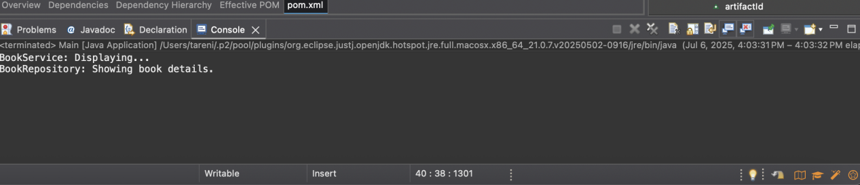

BookService: Displaying...

BookRepository: Showing book details.